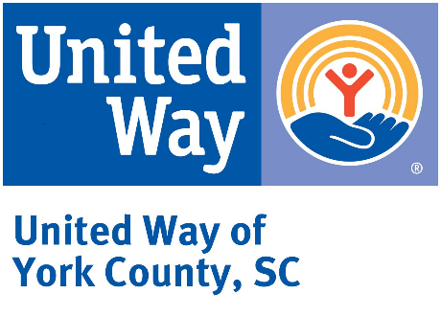

Bold Goal Population Measures:

*Updated 2022* and *Trend Data 2015-2022*

The United Way of York County has identified a Bold Goal of helping 3,000 York County families achieve financial stability by 2030. The following Population Measures represent the data being collected for the focus areas of underemployment and the need for financial literacy. Also, the trend data for the population measures from 2015-2022 and the percentage change for each measure indicate that these measures are all moving in the “right” direction.

**Updated Population Measures, York County (2022)**

|  |  |  |
| --- | --- | --- |
| **Measure** | **Description** | **York County** |
| **Educational Attainment** | Population 25 years and over; less than 9th grade, 9th to 12th grade, no diploma | **14,814**  (7.8%) |
| **Employment Status** | Population 16 years and over; “Unemployed” (excludes students) | **6,947**  (3.1%) |
| **Income below $25,000** | Families with incomes below $25,000 | **4,764**  (6.2%) |
| **Median Income** | Median family income | **$102,752** |
| **Households by Type** | Married-couple household | **57,527**  (52.8%) |
|  | Female householder, no spouse/partner present | **28,919**  (26.5%) |
| **Housing Tenure** | Occupied housing units | **109,013** |
|  | Owner-occupied | **79,206**  (72.7%) |
|  | Renter-occupied | **29,807**  (27.3%) |
| **Poverty Rates** | All families | **5.4%** |
|  | Female householder, no spouse present | **17.0%** |
|  | All people | **8.4%** |
|  | Under 18 years | **10.4%** |
|  | 18 to 64 years | **7.7%** |
| **Rent as a Percentage of Household Income** | Paying 30% of income on rent | **12,953**  (46.6%) |

The following table presents trend data and percentage change from 2015 to 2022 for the Population Measures.

**Population Measures, York County**

***2015 – 2022, Percentage Change***

|  |  |  |  |  |
| --- | --- | --- | --- | --- |
| **Measure** | **2015** | **2022** | **Trend** | **% Change** |
| Educational Attainment,  *Individuals w/ <HS education* | 11.6% | 7.8% | **-3.8%** | **n/a** |
| Employment Status, *Unemployed* | 5.9% | 3.1% | **-2.8%** | **n/a** |
| Families with Income below $25,000 | 14.7% | 6.2% | **-8.5%[1]** | **n/a** |
| Median family income | $66,273 | $102,752 | **n/a** | **+55.0%** |
| Health Insurance Coverage, *no health insurance* | 11.9% | 8.1% | **-3.8%** | **n/a** |
| Poverty Rate, *All families* | 10.5% | 5.4% | **-5.1%** | **n/a** |
| Poverty Rate, *Families with female householder, no spouse present* | 31.3% | 17.0% | **-14.3%** | **n/a** |
| Poverty Rate, *All People* | 13.5% | 8.4% | **-5.1%** | **n/a** |
| Poverty Rate, *Under 18 years* | 18.0% | 10.4% | **-7.6%** | **n/a** |
| Poverty Rate, *18 to 64 years* | 12.7% | 7.7% | **-5.0%** | **n/a** |
| Households by Type, *Total Households* | 90,322 | 109,013 | **n/a** | **+20.7%** |
| Households by Type, *married-couple household* | 53.4% | 52.8% | **-0.6%** | **n/a** |
| Households by Type, *Female householder, no spouse present* | 13.7% | 26.5% | **+12.8%** | **n/a** |
| Housing Tenure, *Occupied housing units* | 92.3% | 94.5% | **+2.2%** | **n/a** |
| Housing Tenure, *Owner-occupied* | 71.7% | 72.7% | **+1.0%** | **n/a** |
| Housing Tenure, *Renter Occupied* | 28.9% | 27.3% | **-1.6%** | **n/a** |

**Next Steps**

Continue to annually track Population Measures for York County and share findings with United Way of York County’s Board, stakeholders, community partners, and community members. Additionally, align these Population Measures with the quarterly Performance Measures being submitted by community partners and compiled by UW of YC staff.

|  |
| --- |
| ***Bold Goal: Help 3,000 York County families achieve financial stability by 2030*** |

**LIVE UNITED**

**GIVE. ADVOCATE. VOLUNTEER.**

[www.unitedwayofyc.org](http://www.unitedwayofyc.org)

**January 2024**

1. This trend represents a decrease of 4,678 families with incomes below $25,000 from 2015 to 2022 (total number of families increased by 11,993 during same time period).